**COMPUTER NETWORKS LABORATORY-1**

BASIC NETWORKING COMMANDS

EXP NO.1 NAME: SHYAMALA R.B.

DATE: 03.08.2023 REG NO.: 2021503558

Command 1: ifconfig

1. ifconfig

-Used to configure the kernel-resident network interfaces.

-Usually used when needed during debugging or for system tuning

-Used to assign IP address to an interface

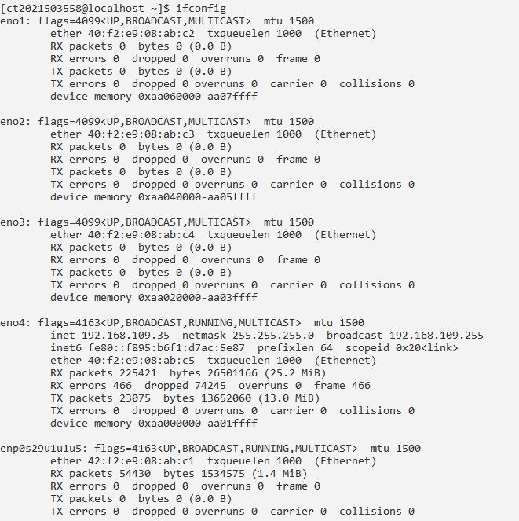

1. Ifconfig –a

-Used to display all the interfaces available, even if they are down

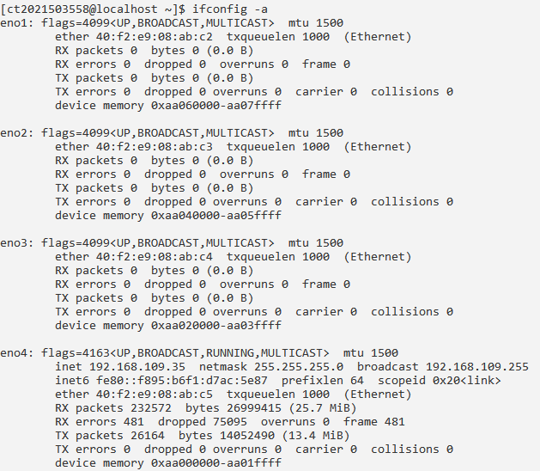

1. Ifconfig –s

-Displays a short list instead of details

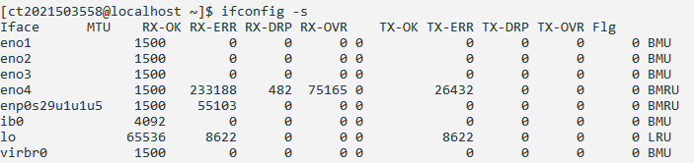

1. Ifconfig –v

-Runs the command in verbose mode, logs more details about execution

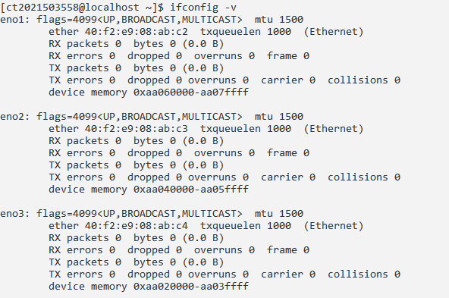

1. Ifconfig --help

- Display help related to ifconfig command

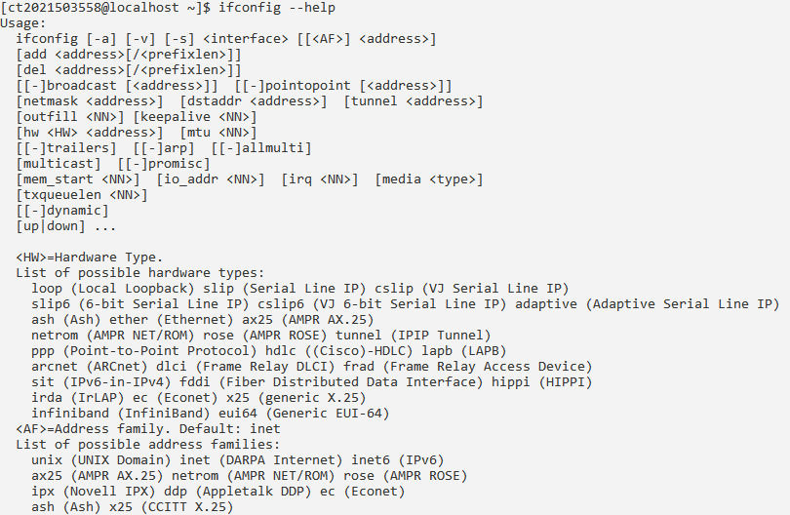

Command 2: nslookup

1. Nslookup

-Name server lookup

-Used for getting information from the DNS server

-Network administration tool for querying the Domain Name System

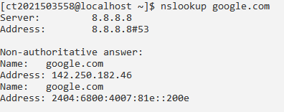

1. Nslookup –type=any gmail.com

-Displays all the available DNS records

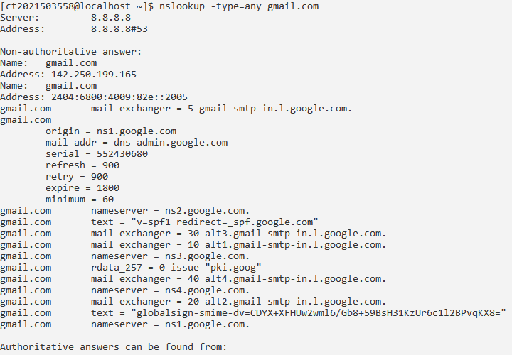

1. Nslookup –type=soa gmail.com

-Lookup for a soa record SOA record (start of authority)

-Provides the authoritative information about the domain the e-mail address of the domain admin, the domain serial number, etc.

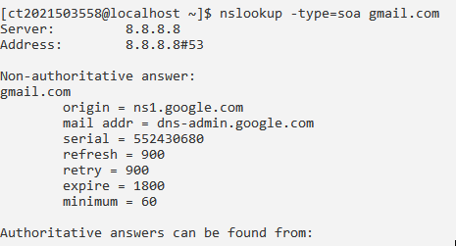

Command 3: traceroute

1. Traceroute

- Used for tracking the route (hop) chosen by a Network packet while reaching the next host

- For each hop, Traceroute command can give detailed information of the traveled route by packets

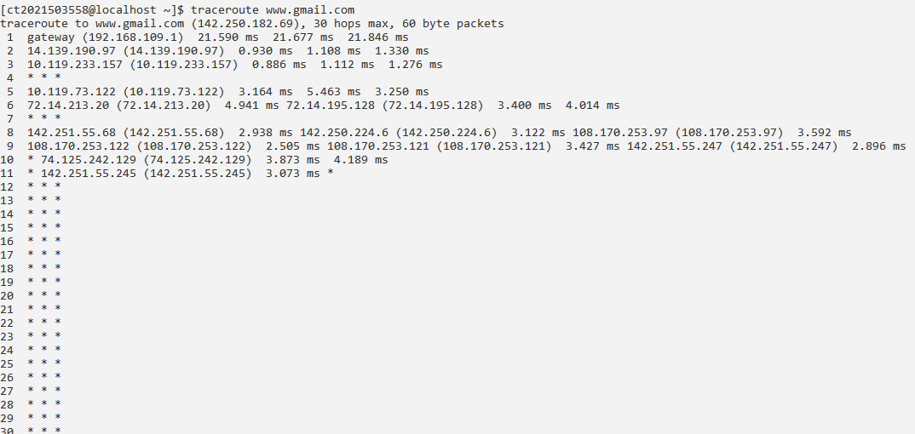

1. Traceroute –m <maximum_hops> gmail.com

-Gives the maximum number of hops to search for target

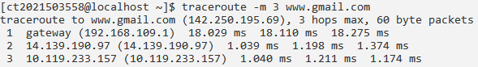

1. Traceroute -4 gmail.com

-Uses Ipv4

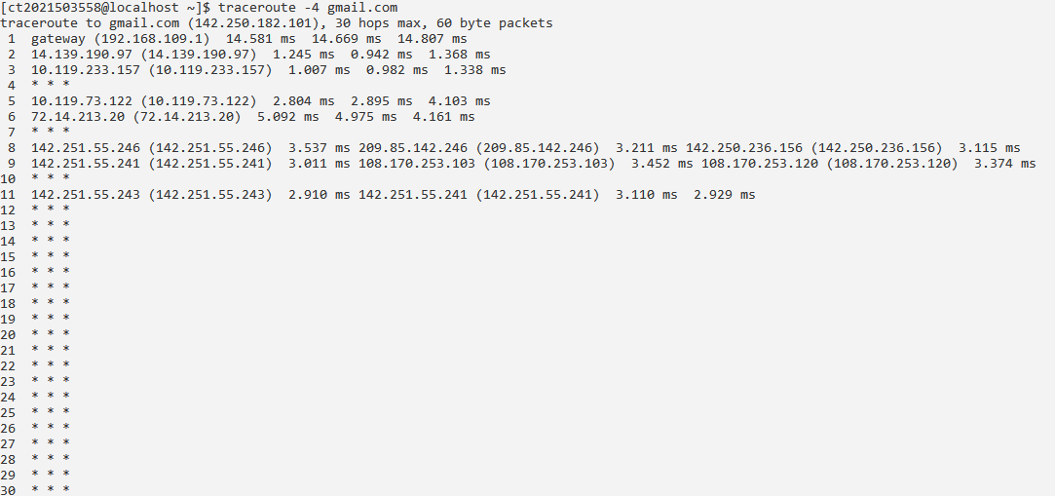

Command 4: ping

- Packet Internet Groper

- Used to check the network connectivity between host and server/host

1. ping –c count gmail.com

- Number of echo requests to send.

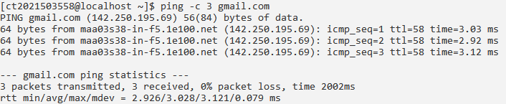

1. ping –l size gmail.com

- Send buffer size

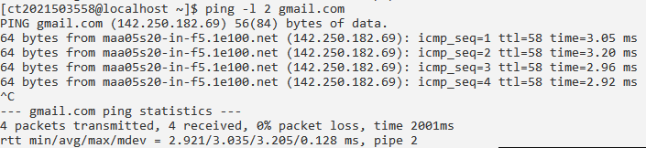

1. ping –w timeout gmail.com

-Timeout in milliseconds to wait for each reply.

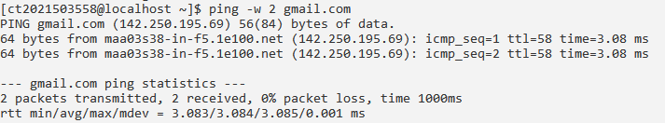

Command 5: host

- Used to find the IP address of a particular domain name

- Used to find out the domain name of a particular IP address

1. host

- Prints the general syntax of the command along with the various options that can be used with the host command as well as gives a brief description about each option.

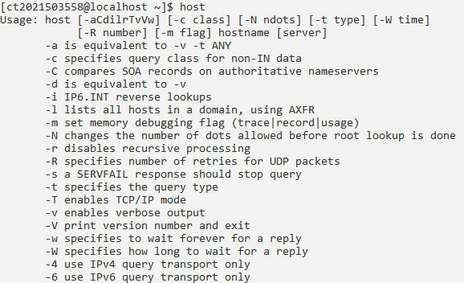

1. host –t ns gmail.com

-Specifies the type of query

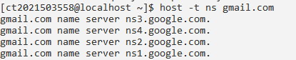

1. host –C gmail.com

-Compares the SOA records on authoritative name servers

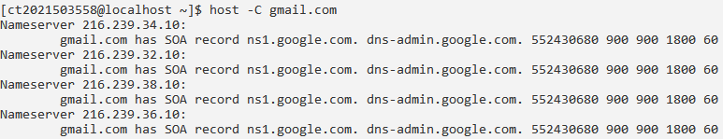

Command 6: route

- Using this command, Linux administrators and users can establish static routes, enabling precise control over network connectivity and optimizing data transmission

1. route

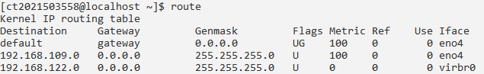

1. route –n

-To display routing table in full numeric form

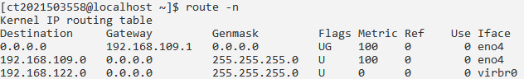

1. route –Cn

- To list Kernel’s routing cache information



Command 7: ssh

- Stands for Secure Shell

- Used to securely connect to a remote server/system.

-Secure in the sense that it transfers the data in encrypted form between the host & the client.

Ssh

- Prints the general syntax of the command along with the various options that can be used with the host command as well as gives a brief description about each option.

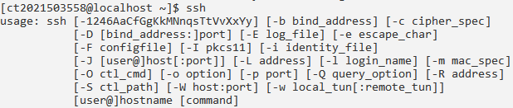

1. Ssh -4

-Allows only IPv4 addresses

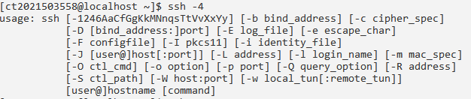

1. Ssh -6

-Allows IPv6 addresses only.

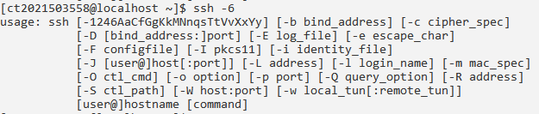

1. Ssh –A

-Authentication agent connection forwarding is enabled

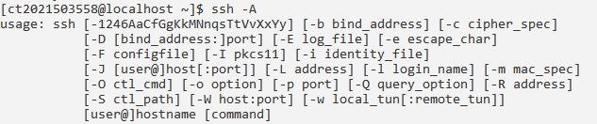

Command 8: dig

-Domain Information Groper

- Used for retrieving information about DNS name servers

1. Dig

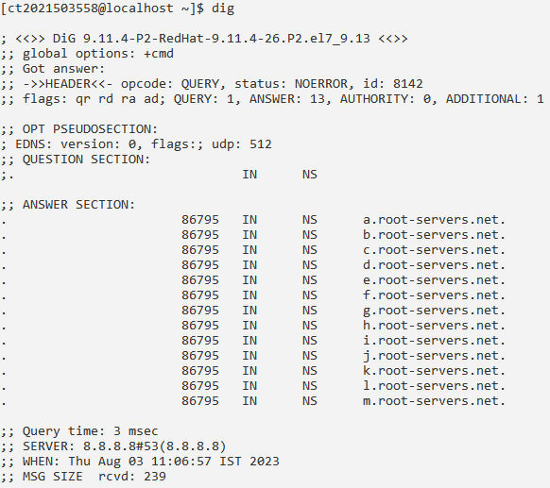

1. dig gmail.com

-Digs up for IPv4 IP record for the domain name gmail.com

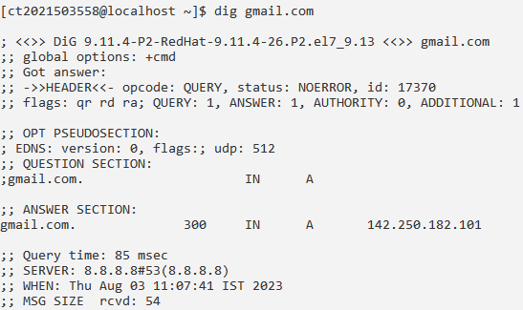

1. dig gmail.com +nocomments

-Removes the comment lines

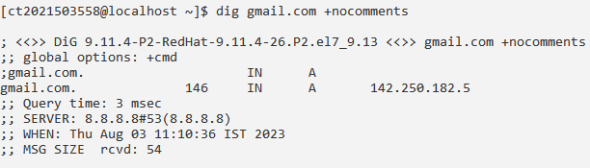

Command 9: who is

- Used to retrieve information about domain names, IP addresses, and network devices registered with the Internet Corporation for Assigned Names and Numbers (ICANN).



Command 10: tcpdump

- Packet sniffing and packet analyzing tool for a System Administrator to troubleshoot connectivity issues in Linux

1. sudo tcpdump

-  Capture the packets from the current interface of the network through which the system is connected to the internet

1. sudo tcpdump -i wlo1

- Captures packets from a specific network interface

1. sudo tcpdump -c 4 -i wlo1

-Captures specific number of packets